# File permissions in Linux

Don Wickramanayake

## Project description

## In this project I will learn to utilize Linux and how to communicate with the OS through its shell. I'll utilize the command line to communicate with the OS. I learnt how to input commands in the shell and learnt about some of the core Linux commands that we'll use as a security analyst. Specifically, this includes navigating and managing the file system. Main part of managing file system is learning about file permission and how to edit it.

## Check file and directory details

## explore the permissions of the projects directory and the files it contains. The lab starts with /home/researcher2 as the current working directory. With the command **cd projects** we can navigate to the projects directory.

Once you navigate to projects directory you can use the command **ls -l** to list the contents and permissions of the projects directory.

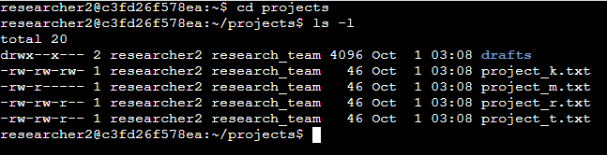

**ls -a | Lists all the hidden files.**

**ls -l | Lists permission to files and directories.**

**ls -la | Lists permission to files and directories including hidden files.**

## Describe the permissions string

In Linux, permissions are represented with a 10-character string.

r – read | Ability to read the file content.

w – write | Ability to make modifications to file content.

x – execute | Ability to execute the file if it is a program.

Permissions are given to three types of owners in below order:

1. User
2. Group
3. Other

First character of the permission string always represents the file type (if it is a directory or file)

d | directory

- | regular file

Ex:

1. **drwx--x--- 2 researcher2 research_team 4096 Oct 1 03:08 drafts**

Above example 1 shows that this is a directory called drafts.

1. **-rw-rw-rw- 1 researcher2 research_team 46 Oct 1 03:08 project_k.txt**

Above example 2 shows that this is a file called project_k.txt

## **d** r w x r w x r w x

User

Group

Other

## Change file permissions

We can use **chmod** command to change file permissions. There are two arguments in the command. First argument indicates how to change the permission, and second argument indicated file or directory you want to apply the permission changes.

Ex: As shown in below example we have made a permission change to project_k.txt file by removing write permission from owner type of other.

Plus sign (+) indicates adding permission while minus sign (-) indicates removing permission.

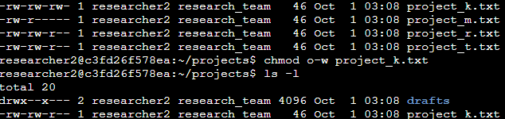

## Change file permissions on a hidden file

Changing file permissions on a hidden file is done in the same way as mentioned earlier. But in order to display the hidden files we have to use **ls -la** command and see what permissions are given to the hidden files. Hidden files are represented with a dot (.) in front of the file name.

Ex: .project_x.txt is a hidden file

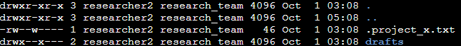

## Change directory permissions

We use the same **chmod** command to change directory permissions.

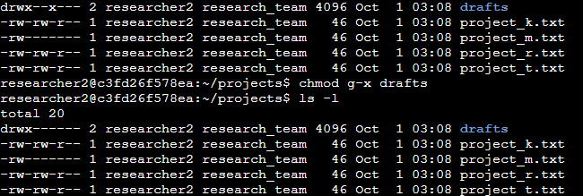

## Summary

Using commands such as **ls**, **ls -a**, **ls -la** and **chmod** we can manage directory and file permissions.